Nomination form
Walda Blow Award
COMMISSION FOR CHILDREN AND YOUNG PEOPLE
Walda Blow Award
This award was established in partnership with the Victorian Commissioner for Aboriginal Children and Young People, in memory of Aunty Walda Blow - a proud Yorta Yorta and Wemba Wemba Elder who lived her life in pursuit of equality.
Amongst her many contributions over 40 years of service to the Victorian Koori community, Aunty Walda:
- was an early founder of the Dandenong and District Aboriginal Cooperative
- established the Women’s Interfaith Network
- for 21 years managed the Margaret Tucker Hostel which provided supported accommodation for young Aboriginal girls and their children aged 15 to 18 years
In her name this Award recognises contributions of an Aboriginal person in Victoria to the safety and wellbeing of Aboriginal and/or Torres Strait Islander children and young people.
For more information on Aunty Blow please visit the Aboriginal Victoria – Aboriginal Honour Roll web-site:
http://www.vic.gov.au/aboriginalvictoria/community-engagement/leadership-programs/aboriginal-honour-roll/2014-victorian-aboriginal-honour-roll/walda-blow.html

Instructions
- Please read the terms and conditions before you commence your nominations. This covers important information such as eligibility, nomination process, screening and judging.
  - Please complete all sections of the nominations form.
  - We encourage you to attach a photo of the nominee with the nomination form. However, if you are unable to do so, this will not impact on your ability to submit your nomination.
  - You cannot nominate yourself.
For more information please read through the nominations guide and writing tips available for download at Victorian Protecting Children Awards <http://www.dhhs.vic.gov.au/protectingchildrenawards>. Alternatively you may wish to contact the Commission for Children and Young People
(e): ccyp.kae@ccyp.vic.gov.au or via phone on 1300 78 29 78
Nominations must be received by 5.00 pm Wednesday 15 May 2019. Please email your nominations to email address or send via post to:
Commission for Children and Young People
Koori Advisory and Engagement team, Level 18/570 Bourke Street, MELBOURNE 3000

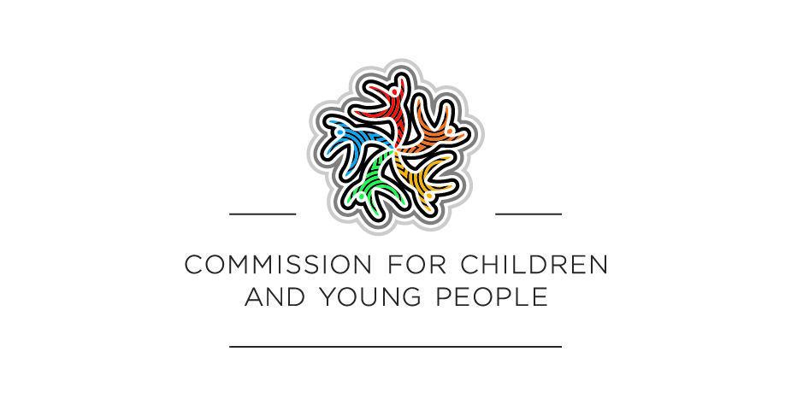

Nomination form
Walda Blow Award

Nominator details
First name
Last name
Job title
Organisation
Phone
Email
Relationship to nominee
The nomination form and related information will be handled in accordance with the Department of Health & Human Services Privacy Policy and the Privacy and Data Protection Act 2014 <http://www.austlii.edu.au/au/legis/vic/num_act/padpa201460o2014317/>.

Please mark with an ‘x’ to confirm you have read and accept the terms and conditions incorporated throughout the nomination form.

Type of nomination
Nominations are open to individuals, teams or groups.
Please mark the nomination type with an ‘X’.
Individual (see page 3)
Teams/Groups (see page 4)

Nominee details – Individual

First name
Last name
Job title
Organisation
Address
Suburb
Postcode
Phone
Email
To your knowledge, has the nominee been subject to disciplinary action within the child protection sector? Please mark with an ‘X’.
Yes |  | No |  | Unsure

Please note:
- Shortlisted nominees will be subject to police checks and carer register screening (co-ordinated by DHHS).
- Shortlisted nominees will be asked to provide high quality photographs and biographies at a specified time.
- Shortlisted nominees will be expected to attend the Awards Ceremony in Melbourne CBD in September 2019 (date to be confirmed).
- Awards recipients (with prior consent) may have their award details published in several outlets, media releases and promotional materials.

Please mark with an ‘x’ to confirm the nominee is aware of these requirements and has consented to this nomination.

Nominee details – Group
For group nominations, provide contact details of a group representative.
A group could be a team, group or organisation and is defined as:
        - a number of people from the same team working on a project
        - a number of people from different teams working on the same project
        - a number of people who work towards achieving better outcomes for clients
Team members must have played an active role in the outcome of the project/work being nominated.
All correspondence for group nominations will be sent to the group representative. It is the responsibility of the group representative to inform all team members.
If you are the nominator you cannot be included in a group nomination as a group representative or team member.
Group name
Group representative first name
Group representative last name
Job title
Organisation
Address
Suburb
Postcode
Phone
Email
Has any member or members of the nominated group been subject to disciplinary action within the child protection sector? Please mark with an ‘X’.
Yes |  | No |  | Unsure

Please note:
- Shortlisted nominees will be subject to police checks and carer register screening (co-ordinated by DHHS).
- Shortlisted nominees will be asked to provide high quality photographs and biographies at a specified time.
- Shortlisted nominees will be expected to attend the Awards Ceremony in Melbourne CBD in September 2019 (date to be confirmed).
- Awards recipients (with prior consent) may have their award details published in several outlets, media releases and promotional materials.
Please mark with an ‘x’ to confirm I have obtained permission from the appropriate representative of this nominated group.

Nomination statement
The awards will be judged on the relevance of the nomination to the award category (summary of achievement).

Writing your nomination

Summary of achievement:
This section provides the judging panel with an outline of why the nomination is being made. It should be no longer than 100 words and identify the impact of the contribution made by the individual/group.
Provide a summary of what the nominee has done in relation to the selected award category.
<maximum 100 words>

The impact:
This section provides the judging panel with an outline of the impact of the nominee’s contribution. Examples may include:
- How has the nominee/s has made a significant contribution to enhancing/improving safety and wellbeing of vulnerable children and young people?
- How has the nominee/s gone above and beyond their role?
- How has the nominee sought to connect children to their local community and improving their rights?
<maximum 500 words>

Additional information:
This section allows a further 150 words to provide any relevant supporting information that further informs the selection panel and may add value to the nomination.
Relevant materials including documents, images, video and website links may also be included in your submission,
<maximum 150 words>

Referee details
  - Provide contact details of two referees.
  - Attach a supporting letter from each referee (maximum 300 words).
  - One referee must be from a different organisation to the nominee.
  - Referees must be independent from the nominator or nominee.

Referee 1
Name
Job title
Organisation
Phone
Email
Relationship to nominee

Referee 2
Name
Job title
Organisation
Phone
Email
Relationship to nominee

The term ‘Aboriginal’ used in this document refers to Aboriginal and/or Torres Strait Islander individuals, people and communities unless otherwise stated or referenced.

