Regulatory Approach
June 2019
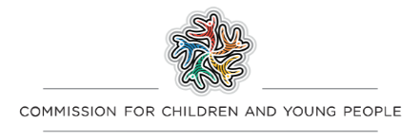

Contents
Our role 1
The regulatory framework 2
Child Safe Standards 2
The Reportable Conduct Scheme 4
A cohesive child safety framework 5
Our regulatory principles 6
Driving continuous improvement 7
Co-regulation and collaboration 7
Who we work with 8
A graduated approach to regulation 10
Compliance and enforcement activities 10
Risk-based approach 12
Considerations of a compliance and enforcement approach 13
The circumstances of the organisation 14
The nature of the compliance issue 15
The impact of co-regulators 15
The strategic impact of our actions 15
Commission for Children and Young People
Level 18, 570 Bourke Street, Melbourne Victoria 3000
Phone (Free call) : 1300 78 29 78
Phone: (03) 8601 5281
Email: contact@ccyp.vic.gov.au
Website: ccyp.vic.gov.au

Our role
We educate, support and regulate organisations that work with children and young people to prevent abuse and implement child safe practices.
The Commission for Children and Young People is responsible for administering the Child Safe Standards (Standards) and the Reportable Conduct Scheme (Scheme). Our regulatory role and functions are set out in the Child Wellbeing and Safety Act 2005 (the Act).
Children and young people have the right to feel safe and be protected from physical, sexual and emotional abuse and serious neglect. The principle that everyone in the community has a role in promoting the wellbeing and safety of children is enshrined in the Act. Child safe organisations are an important part of protecting children from harm.
Our regulatory role stems from government action in response to concerns that many organisations have not done enough to protect the children and young people in their care. These concerns have been extensively investigated through state and national inquiries, including a parliamentary inquiry in Victoria (Inquiry into the Handling of Child Abuse by Religious and other Non-Government Organisations) and the Royal Commission into Institutional Responses to Child Sexual Abuse (Royal Commission).
Our regulatory priorities and approach are informed by the findings and recommendations of these inquiries.
In addition to a Principal Commissioner, the Commission also has a Commissioner for Aboriginal Children and Young People. We are committed to ensuring that our operations and interactions are inclusive of the needs of Aboriginal communities, children and young people. This means that we acknowledge the harms done to the first peoples of Victoria, the legacy of which continues today.
Our approach to regulation is guided by the government’s vision to increase self-determination for Aboriginal people and to ensure that all Aboriginal children and young people are safe and can thrive in culturally rich and strong Aboriginal communities.
In addition to our regulatory responsibilities, we have an oversight and monitoring role with a focus on vulnerable children. We also advocate for children and young people and provide advice to government on issues, policies, services and laws that impact them. We draw on the information and learnings acquired through performing these other roles when performing our regulatory roles.

The regulatory framework
Child abuse can occur in any organisation. We know that some types of activities and organisations are inherently more risky for children. It is possible to better protect children from abuse in all organisations by generating organisational cultures where everyone takes responsibility for protecting children and young people, children and young people are valued and listened to when they raise concerns, and abusive or harmful behaviour is acted on and not tolerated.
The Commission’s objective is to serve the public interest by promoting the safety of children, the prevention of child abuse and the proper response to allegations of child abuse.
Our regulatory roles are designed to support and reinforce the implementation of good practices in organisations, and to respond if organisations continue practices that put children or young people at unacceptable levels of risk.

Child Safe Standards
The Standards are a set of mandatory requirements that certain organisations that provide services or facilities for children, or engage children, must comply with. They promote the safety of children by requiring organisations to implement policies and practices to prevent, respond to and report allegations of child abuse.
The Standards are intended to be applied in a flexible way to recognise that each organisation that works with children and young people is different. There is no ‘one size fits all’ approach to implementing the Standards. Each organisation must consider the ways in which it engages with young people and the specific risks of child abuse present in its operations to determine how best to apply the Standards.
The performance-based nature of the Standards requires organisations to review and modify their approach continuously in order to address new and emerging risks to children and young people within their operations, programs and activities.
Our regulatory role is based upon a co-regulatory model. We share regulatory responsibility with co-regulators (known as ‘relevant authorities’ in the Act) who have a range of ways to drive organisations’ compliance with the Standards. This approach encourages collaboration between the Commission and co-regulators in performing this collective responsibility.
For organisations that do not have a regulator, we are the sole authority enforcing compliance with the Standards.
Our objective when administering the Standards is to promote continuous improvement by organisations so that:
- children’s safety is promoted
- child abuse is prevented
- allegations of child abuse are properly responded to.
We have the following functions in relation to the oversight and enforcement of compliance with the Standards:
- educating and guiding co-regulators and relevant organisations
- overseeing and enforcing organisations’ compliance with the Standards.
In exercising our functions, we consider the most effective means of promoting compliance with the Standards and collaborate and liaise closely with co-regulators.

The Reportable Conduct Scheme
While the focus of the Standards is to prevent abuse, the Scheme provides a central point of oversight for how organisations manage allegations of inappropriate or abusive conduct by their workers or volunteers towards children. The principle that the protection of children is the paramount consideration in the context of child abuse or employee misconduct involving a child is enshrined in the Act.
The Scheme applies to organisations with a high level of responsibility for children (called ‘entities’ under the Act) and sets out specific obligations for the heads of these organisations.
Under the Scheme, heads of organisations are required to have systems in place to prevent abuse, notify the Commission of reportable allegations, ensure investigations are thorough and rigorous, and tell the Commission of any outcomes or findings.
The Act recognises that regulators of organisations and employees have specific knowledge of the areas and professions that they regulate and that they may play an important role in the investigation of reportable allegations. We have an obligation to liaise with these co-regulators to avoid unnecessary duplication and to share information and provide advice about the protection of children.
Our objectives in relation to administering the Scheme are to:
- improve organisations’ ability to identify reportable conduct and to report and investigate reportable allegations
- ensure that reportable allegations are properly investigated
- protect children by working with organisations,
- co-regulators and other relevant bodies to prevent reportable conduct from occurring
- share information with the Secretary to the Department of Justice and Community Safety to support Working with Children Check reassessments.
In administering the Scheme, we have the following functions:
- educating and providing advice to organisations to assist them to identify reportable conduct and to report and investigate reportable allegations
- educating and providing advice to co-regulators to promote compliance by organisations with the Scheme
- overseeing the investigation of reportable allegations
- under certain circumstances, investigating reportable allegations and making findings and recommendations
- under certain circumstances, investigating whether reportable allegations have been appropriately handled by an organisation or co-regulator and making findings and recommendations
- monitoring the compliance of organisations with the Scheme
- exchanging information with Victorian Police, co-regulators and Working with Children Check Victoria
- reporting to the Minister and Parliament on trends related to the Scheme.

A cohesive child safety framework
The Standards and the Scheme are designed to complement each other by driving a culture of child safety and ensuring organisations properly investigate and respond to allegations of inappropriate or abusive conduct towards children.
Our regulatory approach is an integrated model that recognises this. We take a holistic approach, focusing attention on the culture and systems of organisations, as well as providing oversight to ensure individual allegations of inappropriate or abusive conduct towards children are properly reported and investigated through the Scheme.
We use information gathered through the Scheme to inform our actions in administering the Standards, and vice versa.
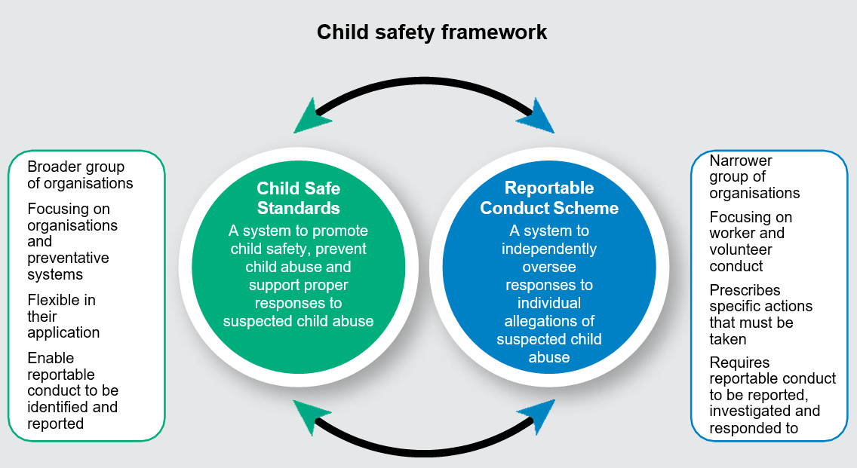

Our regulatory principles
Our regulatory approach is underpinned by our regulatory principles. These explain how we perform our functions, exercise our powers and engage with the regulated community.
We are committed to being:
- Outcomes focused: we prioritise the safety of children and young people. We seek to change practices and behaviours among organisations to minimise the risk of harm to children and young people.
- Collaborative: we seek to partner and collaborate with co-regulators, law enforcement and other government departments in recognition of our shared responsibility to protect children and young people.
- Supportive: we are a reliable and credible authority on child safety and the responsibilities of individuals and organisations under child safety laws. We actively engage with those we regulate, government departments and co-regulators to increase and support their capacity to comply, build skills and knowledge, and prevent child abuse.
- Risk-based: risk guides our decisions, our allocation of resources and our prioritisation.
- Fair: we operate on principles of fairness and respect. We understand and respect the diversity of the organisations we regulate and the individuals impacted by our decisions. Compliance and enforcement activities are undertaken with fairness, impartiality, balance and integrity.
- Efficient and effective: we allocate our resources in a proportionate way and in a way that aims to achieve outcomes in the most efficient way possible.
- Reflective: we review and refine our regulatory approach over time. We recognise that, as a relatively new regulator with a new regulatory framework, our approach must shift as the regulatory environment matures.

Driving continuous improvement
The Commission promotes continuous improvement by organisations in the ways in which they promote the safety of children, prevent child abuse and respond to allegations of child abuse.
Properly implementing the Standards requires organisations to review and revise their systems regularly to ensure that new and emerging risks are identified and addressed and a culture of child safety is maintained.
Likewise, organisations should review and seek to continuously improve the systems, policies, training and processes they have in place to comply with the Scheme.

Co-regulation and collaboration
Many organisations and individuals that work with children are overseen by co-regulators. Co-regulators can work with organisations to support and promote compliance with both the Standards and the Scheme.
Our approach seeks to use existing relationships between our co-regulators and organisations to reduce duplication, while always prioritising child safety.
We liaise with Victoria Police and Child Protection if we have concerns for anyone’s immediate safety.
We share information with co-regulators and other agencies to assist them to perform their role of excluding unsuitable people from continuing to work with children. We also share information to assist co-regulators to take action to support child safety.
Preventing child abuse requires community-wide effort and the Commission cannot achieve this alone. Sometimes the statutory functions and powers of the Commission may mean we are not best placed to take action. In these circumstances, we will collaborate with co-regulators, government departments or Victoria Police.

Who we work with

Victoria Police
If a reportable allegation, or information uncovered while administering the Standards, involves suspected criminal behaviour we notify Victoria Police.
A police investigation into reportable allegations takes priority over a reportable conduct investigation. An organisation’s investigation must be put on hold until the police agree it may proceed.
We liaise with Victoria Police where relevant and may also seek information relating to police investigations to facilitate proper administration of the Scheme and Standards. The Commission supports the appropriate sharing of police information with co-regulators and organisations, in consultation with police, to support child safety.

Relevant authorities
Relevant authorities have an important role in overseeing and promoting compliance with the Standards. Relevant authorities include departments and the Victorian Registration and Qualifications Authority.
We work collaboratively with these co-regulators to enforce the Standards. The Commission also provides advice and educates relevant authorities to assist them to promote compliance by organisations with the Standards.

Regulators of organisations and individuals
Regulators of organisations and individuals have specific knowledge of the organisations and individuals they regulate, and the Commission will collaborate with these co-regulators to ensure the fair, effective and timely investigation of reportable allegations and administration of laws to support children’s safety.
We will share information about reportable conduct allegations and investigations with co-regulators, and substantiated reportable conduct findings with Working with Children Check Victoria, where appropriate.
We may also request that a co-regulator share information with the Commission, or in certain circumstances, that the co-regulator investigate a reportable allegation.
The Commission educates and provides advice to co-regulators to promote compliance by organisations with the Scheme.

Other organisations
We may also collaborate and share information with other types of organisations such as peak bodies and associations to promote children’s wellbeing and safety.

A graduated approach to regulation
We take a graduated approach to achieving compliance by the organisations we regulate. In many instances, we can bring about compliance through education and support, with more significant sanctions being used for organisations that are uncooperative or that have repeated or serious failings in compliance, or where greater harm or significant risk of harm to children has been identified.
However, a graduated approach does not mean that regulatory tools must be used sequentially, nor that we will hesitate with enforcement when circumstances require. In each case, we consider the full range of options available and take a balanced and proportionate approach.
Our approach to regulation is to assist individual organisations and sectors to develop an understanding of compliance requirements and ways to keep children safe in order to generate a robust culture of child safety. With our advice and guidance, organisations should develop their own systems to prevent, and respond to, allegations of inappropriate and abusive conduct against children. Our priority is to build the capacity, knowledge and skills of organisations to develop a culture of child safety in a way that best suits the nature of their organisation and the children within it.
We take a risk-based approach to monitoring, assessing compliance and enforcement. Usually, statutory enforcement action involving notices, orders, penalties and fines will only be taken where efforts to advise organisations on how to comply have been attempted.
We believe that children should experience consistent levels of safety within organisations that we regulate. While risk will guide our decisions, our aim is to achieve the greatest possible level of compliance across a wide range of diverse organisations, not just those organisations that present the highest risk to children.

Compliance and enforcement activities
Inform and educate:
- raise general awareness of the Standards and Scheme and requirements for compliance
- provide accessible guidance material and tools to support compliance
- conduct information sessions, education, training and workshops for organisations and co-regulators
- conduct awareness-raising activities and develop guidance aimed at specific sectors to best support them to comply
- respond to requests for advice, assistance, information and enquiries
- collaborate with co-regulators to promote consistent compliance by all organisations.
Support to comply:
- where non-compliance is identified, provide advice and guidance to organisations to:
  - understand what compliance looks like
  - identify, prioritise and manage the risks to child safety
- provide practical advice on compliance where gaps are identified, and guide organisations and co-regulators on how to achieve compliance.
Monitor compliance:
- investigate and respond to concerns about alleged non-compliance by an organisation
- where non-compliance has been identified, monitor efforts by organisations to remedy significant gaps and generate child safety
- request documents and information from organisations, co-regulators and Victoria Police
- inspect an organisation’s premises and documents to assess compliance
- oversee and give guidance to organisations to assist them to properly investigate individual reportable allegations
- conduct an own motion investigation concerning any inappropriate handling of, or response to, a reportable allegation by an organisation or a co-regulator
- share information with co-regulators, Victoria Police and other agencies to support them monitoring compliance with child safety laws
- gather and analyse data to build intelligence regarding trends in non-compliance and the risk profiles of individuals, organisations and sectors.
Enforce the law:
- issue a ‘Notice to Produce’ to gather information to assess compliance or oversee an investigation
- issue a ‘Notice to Comply’ with the Standards to compel action to improve child safety
- request that a co-regulator take action under their applicable law, contract or agreement to achieve compliance with the Standards
- request that a co-regulator of an employee investigate a reportable allegation in respect of that employee
- publish information relating to the operation of the Standards and Scheme, naming specific organisations where it is appropriate
- apply to the court for a declaration of non-compliance with notices and an order requiring the organisation to pay a civil penalty
- prosecute a head of organisation for not notifying the Commission of a reportable allegation within the 3-day period or not providing a 30-day update.
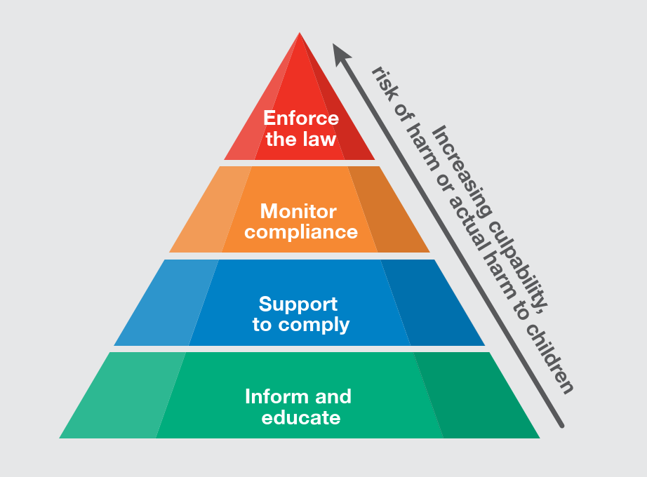

Risk-based approach
The Commission administers a relatively new regulatory framework with the significant task of supporting the development of child safe cultures and practices in more than 50,000 organisations to better prevent and respond to child abuse.
In order to achieve this goal, we must prioritise our work and adopt a strategic approach. Our risk-based framework provides us with guidance to achieve this task.
We identify and assess the risks presented by sectors, organisations and individuals to assist us to make decisions, allocate our resources and prioritise our work.
We consider:
- the risk of child abuse occurring within sectors or an individual organisation
- the risk of an organisation not properly investigating a reportable allegation
- the risk individual workers or volunteers pose to children.
The different types of risk we consider include:
- Situational risk: the activities children are involved in and the opportunities for child abuse to occur.
- Vulnerability risk: the characteristics of children involved in organisations that impact their risk of being abused.
- Institutional risk: an organisation’s attitudes and culture, policies and practices, and capacity.
- Propensity risk: the possibility that perpetrators of child abuse are present in an organisation.
Risk guides our decisions about how we use our compliance and enforcement tools. An understanding of risk assists us to use our available resources and powers to make the greatest difference to Victorian children.
Our risk-based framework is based on available evidence. It will be regularly reviewed and adapted as the evidence, knowledge and information about preventing and responding to child abuse increases and the regulatory environment changes and matures.
We will always consider risk, alongside other factors, when performing our role. 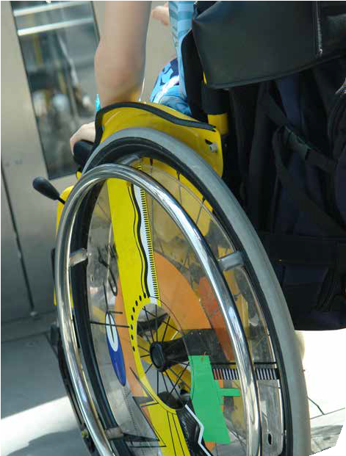

Considerations of a compliance and enforcement approach
The organisations the Commission regulates are diverse. Some are large or heavily regulated. Others are very small or may be otherwise unregulated. Some have paid workers with significant formal training to support them to work with children, and others are staffed solely by volunteers. Some organisations are responsible for the child’s full-time care and others have more fleeting engagement with children.
Recognising the diversity of those we regulate, we do not take a prescriptive approach to responding to risks of child abuse or reportable conduct allegations. We recognise that different sectors and organisations need different approaches for them to comply.
Key factors we consider when choosing a compliance and enforcement approach are the:
- circumstances of the organisation
- nature of the compliance issue
- impact of co-regulators
- strategic impact of our actions.

The circumstances of the organisation
The Commission considers the willingness and capacity of the organisation to achieve compliance. This includes their compliance history or past approach to child safety as well as the context surrounding their behaviour.
We recognise that we are administering a relatively new regulatory framework requiring a great number of organisations to improve their approach to child safety. Organisations will bring a range of attitudes and approaches to this task.
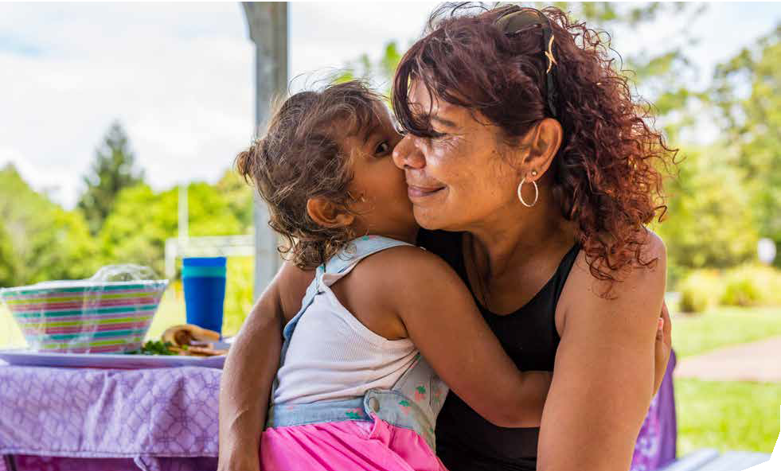
Organisations can be categorised by behaviour that indicates they are:
- willing and able to comply and take all reasonable steps to do so
- willing to comply but unintentionally fail to do so (some organisations will seek to comply but may make errors or misunderstand what is required, and other organisations seek to comply but, through lack of capability or capacity, have been unable to meet the requirements)
- prepared to test the boundaries of the law in order to minimise compliance obligations (these organisations will do the bare minimum they perceive as necessary to comply, and may occasionally ‘cut corners’ or fail to achieve actual compliance through their minimal actions)
- deliberately avoid compliance obligations.

The nature of the compliance issue
We also consider the nature and circumstances of the matter that has brought the organisation to our attention, including:
- serious safety risks to children and young people (for example where there is an immediate and significant risk to children or a serious systemic issue)
- broader repercussions arising from the compliance issue, including the effect on other organisations that have engagement with children, co-regulators or the public if the issue is not adequately addressed.

The impact of co-regulators
We work with co-regulators to avoid duplication of efforts and unnecessary compliance burdens for organisations to make it is as easy as possible for them to be child safe and respond appropriately to allegations of reportable conduct.
It may be more appropriate for the Commission to refer a compliance issue to a co-regulator for action, or to collaborate with a co-regulator to improve compliance.

The strategic impact of our actions
We take into account the need for both specific and general deterrence. We look for opportunities to maximise impact and leverage any outcomes across regulated sectors. For example, we may publicise the results of enforcement activity to encourage other organisations in a sector to change their practices.
About the logo of the Commission for Children and Young People
The logo represents our vision for all children to be strong in health, education, culture and identity, and face the world with confidence.
The people are connected, equal in size and importance, and there is a fluidity that binds them together.
The mission of the Commission is for all young Victorians to achieve these goals.
The symbol is a Koorie design created by Marcus Lee for the Commission.
The Commission respectfully acknowledges the Traditional Owners of the country throughout Victoria and pays respect to the ongoing living cultures of First Peoples.
© Commission for Children and Young People 2019
This work is copyright. Apart from any use as permitted under the Copyright Act 1968, no part may be reproduced by any process without prior written permission from the Commission for Children and Young People.
Commission for Children and Young People Level 18, 570 Bourke Street
Melbourne Victoria 3000
Phone (Free call): 1300 78 29 78
Phone: (03) 8601 5281
Email: contact@ccyp.vic.gov.au
www.ccyp.vic.gov.au

